

Installation Instructions

Insum

Single Sign On Engine

Installation Instructions

Author: Sylvain Martel

Creation Date: May 23, 2016

Last Updated: March 23, 2017

Document Ref: Insum-C2 SSO

Version: 2.2.0

1. **Title, Subject, Last Updated Date, Reference Number**, **and** **Version** are marked by a Word Bookmark so that they can be easily reproduced in the header and footer of documents. When you change any of these values, be careful not to accidentally delete the bookmark. **You can make bookmarks visible by selecting Tools->Options…View and checking the Bookmarks option in the Show region.**

## Document Control

**Change Record**

3

| Date | Author | Version | Change Reference |
| --- | --- | --- | --- |
|  |  |  |  |
| 14-June-09 | C2 Consulting | 1.0.0 | Initial Release (scripts) |
| 2-May-16 | Sylvain Martel | 2.0.0 | No Previous Document (scripts) |
| 25-May-16 | Sylvain Martel | 2.0.1 | Added EBS Pofile Option |
| 25-Jul-16 | Sylvain Martel | 2.0.2 | Added C2 SSO Default Values |
| 8-Aug-16 | Sylvain Martel | 2.1.0 | Review for file names standardization (scripts) |
| 18-Oct-16 | Sylvain Martel | 2.1.1 | Review installation scripts |
| 23-Mar-17 | Sylvain Martel | 2.0.0 | Open Source Version |

**Reviewers**

| Name | Position |
| --- | --- |
|  |  |
|  |  |
|  |  |
|  |  |
|  |  |

Contents

Document Control ii

Installation Instructions for Insum-C2 Single Sign On 1

Description 1

Pre-Installation Steps 1

Database Components 1

APEX Applications 3

EBS Installation and Configuration 3

APEX SSO Default Values 5

Verification Checklist 7

1. To update the table of contents, put the cursor anywhere in the table and press [F9]. To change the number of levels displayed, select the menu option Insert‑>Index and Tables, make sure the Table of Contents tab is active, and change the Number of Levels to a new value.

## Installation Instructions for Insum-C2 Single Sign On

### Description

This document describes the required steps to install the Inasum-C2 Single Sign On Engine for Oracle E-Business Suite.

Refer to the **Verification Checklist** section at the end of this document for a complete list of database objects created by this installation.

### Pre-Installation Steps

#### Requirements

* File system access to $OA_HTML directory as the applmgr user
* Access to database custom schema (ex: XX)
* Access to database schema APPS
* SYSADMIN access in Oracle E-Business Suite
* Access to APEX Builder

### Database Components

#### Installation Summary

* Copy installation files to database server
* Execute installation script for database objects
* Import APEX Applications
* Validate list of database objects created

1. Your steps should be more specific than the examples shown.

#### Copy Installation Files to Database Server

1. Copy the installation directory **xxapex_sso** to your database server or a staging area

The following directory structure should be copied:

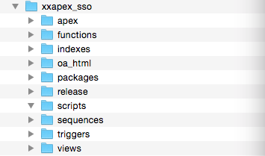

#### Execute Installation Script for Database Objects

1. Log to your database server
2. Change directory to **../xxapex_sso/release**
3. Connect to SQL*Plus as database user **SYSTEM**
4. Execute SQL script **sso_release.sql** indicating 2 parameters:
   1. APPS schema name
   2. Custom schema name

Ex. : @sso_release.sql apps xx

The following SQL scripts will be executed:

**sso_release_xx.sql**

|  |  |  |
| --- | --- | --- |
| **SQL Script Name** | **Location** | **Purpose** |
| create_sso_tables.sql | release | Initial table creation |
| sso_indexes.sql | indexes | Creates initial indexes |
| sso_sequences.sql | sequences | Creates initial sequences |
| sso_triggers.sql | triggers | Creates initial triggers |
| sso_apex_grants.sql | release | Create grants for APPS |

**sso_release_apps.sql**

|  |  |  |
| --- | --- | --- |
| **SQL Script Name** | **Location** | **Purpose** |
| sso_apps_synonyms | release | Create synonyms for PL/SQL package and custom tables |
| sso_packages.sql | packages | Creates initial PL/SQL packages |
| sso_apps_grants.sql | release | Create grants for custom schema |
| sso_apex_synonyms.sql | release | Create synonyms for PL/SQL package and custom tables |

### APEX Applications

The installation of the APEX applications can be done using the APEX builder. Select the files listed below from the **apex** subdirectory:

|  |  |  |
| --- | --- | --- |
| **SQL Script Name** | **Location** | **Purpose** |
| xxapex_sso_administration_app.sql | apex | Maintain partner connections for C2 SSO |
| xxapex_sso_redirect_app.sql | apex | Receives calls from EBS and redirect to the target APEX application |
| xxapex_sso_test_app.sql | apex | SSO Test application to be called from EBS |

### EBS Installation and Configuration

#### Installation Summary

* Copy and compile CallApexSSO.jsp to $OA_HTML directory ($COMMON_TOP/webapps/oacore/html)
* Create Profile Option for Partner Name

1. Your steps should be more specific than the examples shown.

#### Copy CallApexSSO.jsp file

In R12, calling an APEX page is achieved by passing parameters to a JSP file and creates a URL string called by that process. In order to provide this functionality, a custom jsp needs to be created in the $OA_HTML directory on the server.

* Using Filezilla (or any other FTP client software), transfer file **CallApexSSO.jsp** from directory **oa_html** in the installation package to directory $OA_HTML (text format) in EBS

|  |  |  |
| --- | --- | --- |
| **SQL Script Name** | **Location** | **Purpose** |
| CallApexSSO.jsp | oa_html | Custom JSP to call APEX application through C2 SSO |

#### Compile CallApexSSO.jsp file

Changes to the JSP can be recompiled automatically. Typically, this step is not required. The following commands are described for information purposes.

* Log on UNIX using **applmgr** user and execute the following commands:

cd $OA_HTML

export PATH=$PATH:$FND_TOP/patch/115/bin

ojspCompile.pl --compile -s 'CallApexSSO.jsp' --retry

#### Create APEX SSO Partner Name Profile Option

Log in Oracle E-Business Suite as the system administrator (SYSADMIN) and create a profile option to record the Partner Name for the Single Sign On engine.

* Login into E-Business suite and select **System Administrator** responsibility
* Follow navigation menu **Define Profile Option**

| Field | Value |
| --- | --- |
|  | X |
| **Name** | APEX_SSO_PARTNER_NAME |
| **Application** | *[Custom Application]* |
| **User Profile Name** | APEX SSO: Partner Name |
| **Description** | Partner Name to be used by EBS when requesting a URL to connect to any APEX application - Insum |
| **Hierarchy Type** | Security |
| **Active Dates** |  |
| **Start** | *[Today’s Date]* |
| **End** | (NULL) |
| **User Access** |  |
| **Visible** |  |
| **Updatable** |  |

| Hierarchy Type Access Level | Visible | Updatable |
| --- | --- | --- |
|  | X | X |
| **Site** | √ | √ |
| **Application** |  |  |
| **Responsability** |  |  |
| **User** |  |  |

#### Assign APEX SSO Partner Name Profile Option Value

Log in Oracle E-Business Suite as the system administrator (SYSADMIN) and assign a value at the site level to profile option ***APEX SSO: Partner Name***

* Login into E-Business suite and select **System Administrator** responsibility
* Follow navigation menu **Profile > System**

| **Profil Option Name** | **Site** | **Application** | **Responsibility** | **User** |
| --- | --- | --- | --- | --- |
| APEX SSO: Partner Name | *[EBS]* |  |  |  |

Where [EBS] is the name of the Oracle E-Business Suite partner name for Insum-C2 SSO.

### APEX SSO Default Values

#### Validate APEX SSO Default Values

After the APEX SSO installation, validate the default values to be used when creating partners for APEX applications.

* From your favorite browser, go to the APEX SSO Administration application.

Example: http://dev.myserver.com:8080/apex/f?p=SSO_ADMIN

* Click on the Settings link in the menu list

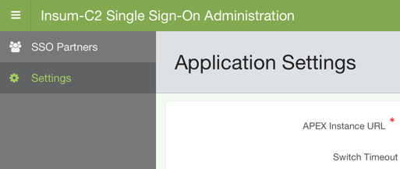

* Enter or validate the values for each field:

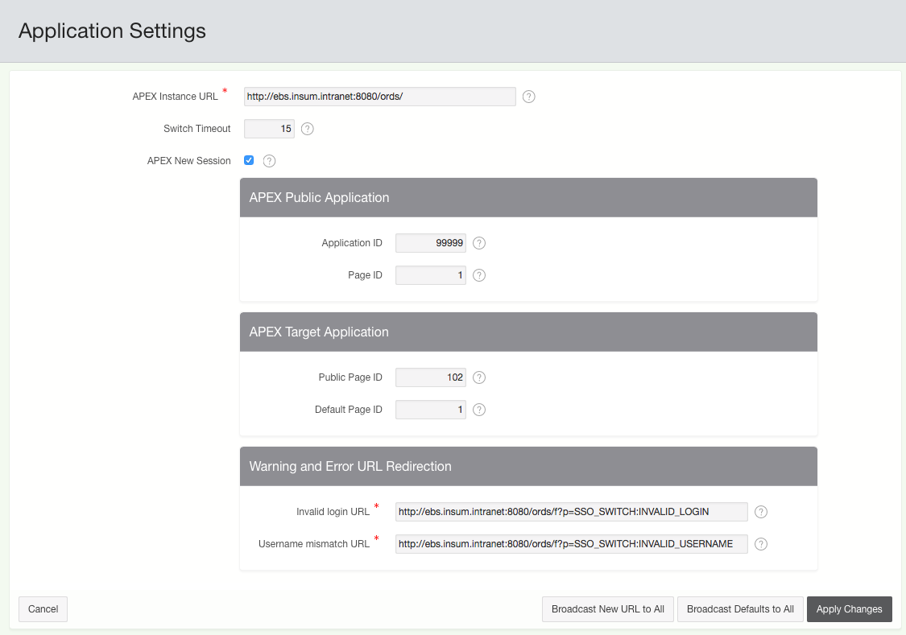

#### Fields Description

* **APEX Instance URL**: This is the URL where APEX applications can be reached at.  
    
  For example: <http://server:port/ords/>

**IMPORTANT:** Make sure the URL ends with a forward slash.

After a clone of the EBS instance, change the URL soi t points to the new APEX instance and click on the **Broadcast New URL to All** button to apply this URL to all the existing partner entries.

* **Switch Timeout**: The switch to the application must happen within this many seconds. A slow network or slow system may require a higher amount of time. Enter a value in seconds between 0 and 300 (5 minutes).
* **APEX New Session**: When selected, a new APEX session will be created every time a user calls an APEX application from the EBS navigator (recommended).

APEX Public Application

* **Application ID**: The application ID of the APEX public application (dispatch application) that a partner needs to call to access the APEX target application.
* **Page ID**: The page ID of the APEX public application. This page will execute the redirection to the APEX target application.

APEX Target Application

* **Public Page ID**: The public page ID of the APEX target application which is called by the APEX public application.
* **Default Page ID**: The default page ID of the APEX target application where the user will land if no page ID is defined when calling the APEX application from the partner.

Warning and Error URL Redirection

* **Invalid Login URL**: Fully qualified URL of the APEX public application to be used when an invalid login is detected. The page defined in this URL will be displayed to the user. This field value applied to all partners and cannot be changed for each partner definition.
* **Username Mismatch URL**: Fully qualified URL of the APEX public application to be used when an username mismatch is detected. The page defined in this URL will be displayed to the user. This field value applied to all partners and cannot be changed for each partner definition.

### Verification Checklist

1. Verify that the installation executed properly by validating that the following objects exists in custom database schema (XX):

|  |  |
| --- | --- |
| **Object Name** | **Type** |
| XXAPEX_SSO_INFO_DEFAULTS | Table |
| XXAPEX_SSO_INFO | Table |
| XXAPEX_SSO_APPS | Table |
| XXAPEX_SSO_LOG | Table |
| XXAPEX_SSO_INFO_BIU | Trigger |
| XXAPEX_SSO_INFO_DEF_BU | Trigger |
| XXAPEX_SSO_APPS_BI | Trigger |
| XXAPEX_SSO_LOG _BI | Trigger |
| XXAPEX_SSO_INFO_S | Sequence |
| XXAPEX_SSO_APPS_S | Sequence |
| XXAPEX_SSO_LOG_S | Sequence |
| XXAPEX_SSO_INFO_PK | Constraint |
| XXAPEX_SSO_INFO_UK1 | Constraint |
| XXAPEX_SSO_APPS_PK | Constraint |
| XXAPEX_SSO_PARTNER_UTILS | Synonym |
| XXAPEX_SSO_PUBLIC | Synonym |

1. Verify that the installation executed properly by validating that the following objects exists in database schema APPS:

|  |  |
| --- | --- |
| **Object Name** | **Type** |
| XXAPEX_SSO_PARTNER_UTILS | PL/SQL Package |
| XXAPEX_SSO_PUBLIC | PL/SQL Package |
| XXAPEX_SSO_INFO_DEFAULTS | Synonym |
| XXAPEX_SSO_INFO | Synonym |
| XXAPEX_SSO_APPS | Synonym |
| XXAPEX_SSO_LOG | Synonym |

**End of document.**